BED 106 — BUSINESS ANALYTICS
Checkpoint 4: Task 4.1 — Predictive Analytics Application
RetailPulse — Poblacion Grocery Mart
Overview
Checkpoint 2 established a strong positive correlation between total revenue and total profit (r = 0.97) and a strong negative correlation between revenue and profit margin percentage (r = -0.71) across the store's 40 products, but did not fit a formal regression equation. This section builds on that groundwork with two predictive models: a multiple linear regression predicting a product's total revenue from its sales volume and price, and a trend-based forecast projecting monthly store revenue three months forward.
Model 1 — Multiple Linear Regression: Predicting Product Revenue
Predictors (X): units_sold, unit_price Outcome (Y): total_revenue Sample: all 40 products
Regression equation:
Total Revenue = -72,824.47 + (123.90 × Units Sold) + (420.51 × Unit Price)
Term | Coefficient | Std. Error | t-stat | p-value
Intercept | -72,824.47 | 36,402.42 | -2.00 | 0.053
Units Sold | 123.90 | 47.30 | 2.62 | 0.013
Unit Price | 420.51 | 20.30 | 20.72 | < 0.001

Metric | Value
R² | 0.9501
Adjusted R² | 0.9474
MAE | ₱15,435.50
RMSE | ₱23,256.82
n (products) | 40

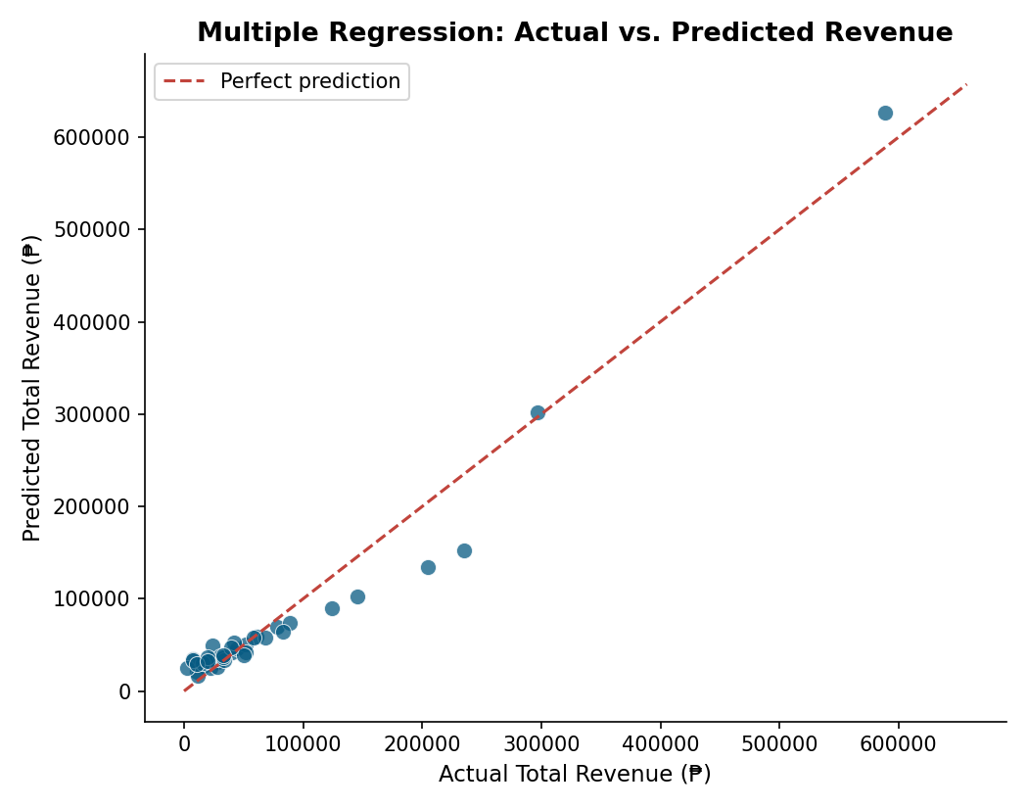
Figure — Actual vs. predicted total revenue per product. Points close to the dashed line indicate accurate predictions.
Interpretation
The model explains 95% of the variation in product revenue (R² = 0.950), and both predictors are statistically meaningful — unit price is highly significant (p < 0.001) while units sold is significant at the 5% level (p = 0.013). Comparing the standardized effect of each coefficient, every additional peso of unit price is associated with about ₱420.51 more in a product's total 6-month revenue, versus roughly ₱123.90 for every additional unit sold. In this store's current product mix, price carries about 3.4 times more revenue leverage than volume — meaning a pricing decision moves total revenue further than a comparable push on sales volume.
Limitations: the model is fit on only 40 products and assumes the price–revenue relationship is linear across the full price range, from ₱3 items to a ₱1,550 rice sack. It should be used for directional guidance (which lever — price or volume — matters more) rather than for precisely forecasting an individual product's revenue, and should be re-fit periodically as pricing and the product mix change.
Model 2 — Trend-Based Forecast: Monthly Store Revenue
A simple linear trend model was fit on monthly total revenue (month index 1–6, January–June 2026) to test whether revenue is growing, declining, or flat, and to project the next 3 months.
Trend equation:
Monthly Revenue = 466,660.27 + (-968.31 × Month Index)
Metric | Value
Slope | -968.31 / month
Slope p-value | 0.939 (not significant)
R² | 0.0017
n (months) | 6

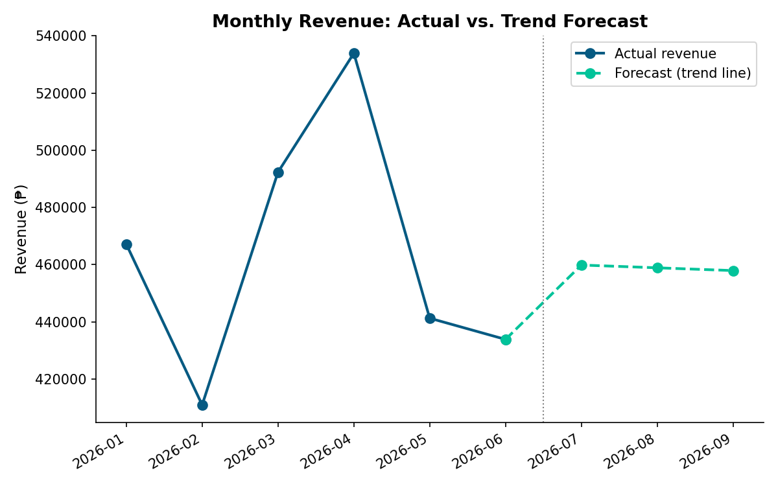
Figure — Actual monthly revenue (Jan–Jun 2026) and trend-based forecast for Jul–Sep 2026.
Interpretation
Unlike the revenue model above, this trend has essentially no statistical significance (R² = 0.002, slope p = 0.94) — month-to-month revenue bounces between ₱411K and ₱534K with no reliable upward or downward trajectory over this 6-month window. The forecast for July–September 2026 is therefore close to flat, hovering around ₱458K–460K per month, which is close to the historical average rather than a genuine projection of growth or decline.
Limitations: six months of data is a short window for trend detection, and no seasonality adjustment was applied. This result should not be read as "revenue will stay flat" — it should be read as "there is no evidence of a trend yet," and the forecast should be revisited once more months of data are available. This is itself a useful, honest finding: any future revenue growth will need to come from a deliberate action (pricing, promotion, or new products) rather than existing momentum.
Business Predictions & Recommendations
1. Prioritize pricing strategy over volume pushes for revenue growth.
Since unit price has roughly 3.4× the revenue impact of units sold, a modest, well-targeted price adjustment on high-volume items (e.g. Rice & Staples) is likely to move total revenue more than a promotional push aimed purely at increasing units sold.
2. Do not assume organic revenue growth without intervention.
With no significant month-over-month trend detected (p = 0.94), the store should not expect revenue to climb on its own. Projected Jul–Sep 2026 revenue is approximately ₱458,000–₱460,000/month absent any changes — flat relative to the 6-month average of about ₱463,271/month.
3. Use the revenue model to evaluate new or repriced products before launch.
For a hypothetical new product priced at ₱150 with an expected 700 units sold over 6 months, the model predicts total revenue of approximately ₱116,349 (-72,824.47 + 123.90×700 + 420.51×150). This kind of what-if estimate can support stocking and pricing decisions before committing shelf space to a new SKU.
4. Re-run the trend forecast quarterly as more data accumulates.
Because the current trend estimate is statistically insignificant, it should be treated as provisional. Refitting the model every quarter with additional months of data will produce a more reliable read on whether real growth or decline is emerging.
Conclusion
Together, these two models tell a consistent story: the store's revenue is currently price-driven and stable rather than trending, and pricing decisions are the most promising lever for deliberate revenue growth going into the next quarter.

